IRIS RECOGNITION SYSTEM

Methods of Iris Recognition being used in our project

In identifying one’s iris, there are 2 methods for its recognition and are:

* + - 1. Active
      2. Passive

The active Iris system requires that a user be anywhere from six to fourteen inches away from the camera.

The passive system allows the user to be anywhere from one to three feet away from the camera that locates the focus on the iris.

Iris Recognition Diagram



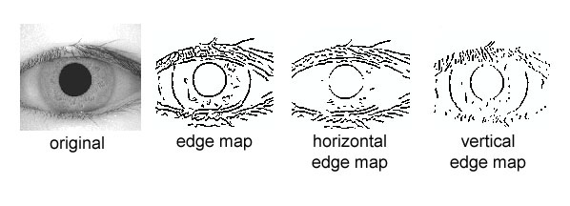

WHAT WE HAVE DONE

SO FAR ?

Firstly, an automatic segmentation algorithm is used , which localizes the iris region from an eye image and isolate eyelid, eyelash and reflection areas.

Automatic segmentation is achieved through the use of the circular Hough transform for localizing the iris and pupil regions, and the linear Hough transform for localizing occluding eyelids. Thresholding is also employed for isolating eyelashes and reflections.

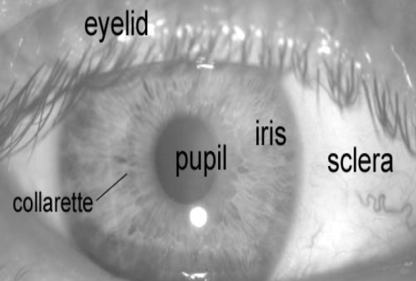 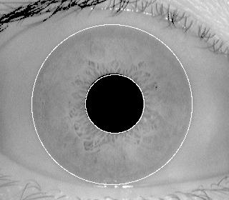

Next, the segmented iris region is normalized to eliminate dimensional inconsistencies between iris regions. This helps in the process of Iris Detection and eliminates any impure / undetected part of the eye or the eyelash from the Database being used .

SCREENSHOTS OF OUT PROGRESS

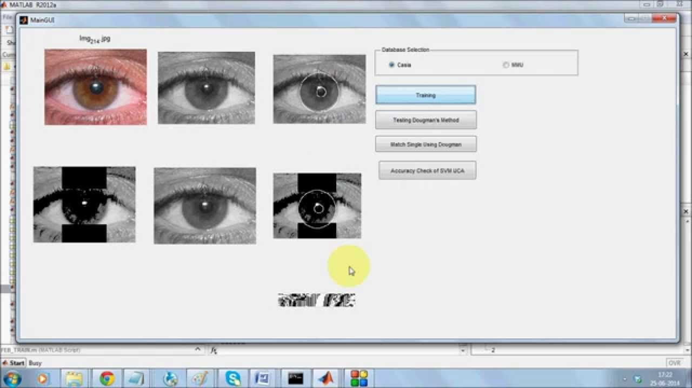

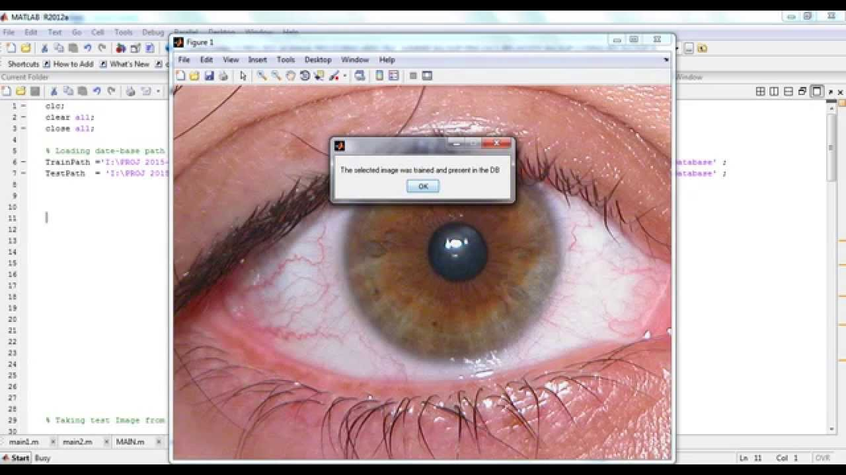

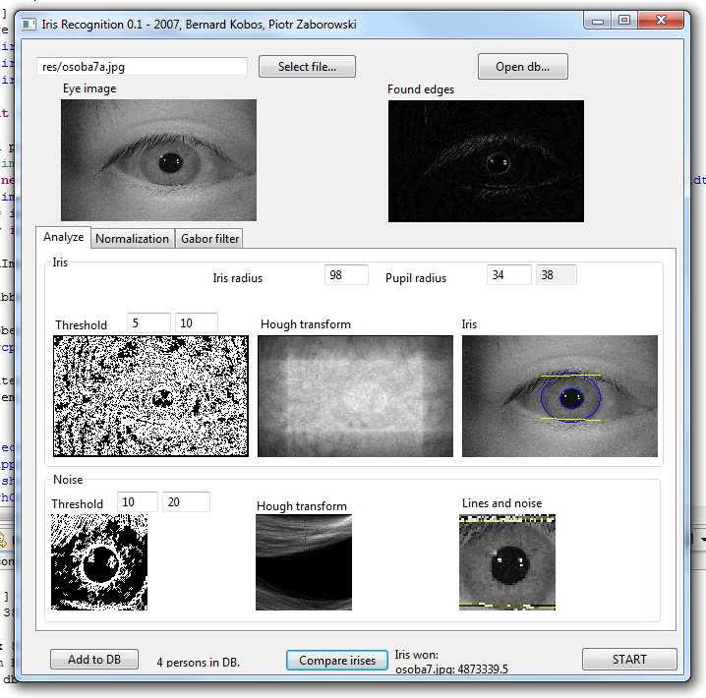

WHATS LEFT TO BE DONE?

The system presented will be able to perform accurately, however there are still a number of task and issues which need to be addressed.

First of all, the automatic segmentation was not perfect, since it could not successfully segment the iris regions for all of the eye images in the two databases. An improvement could also be made in the speed of the system. The most computation intensive stages include performing the Hough transform, and calculating Hamming distance values between templates to search for a match.

Also the UI has to be integrated with additional features to be user friendly and perform other various task as well.

Another extension to the system would be to interface it to an iris acquisition camera. Now rather than having a fixed set of iris images from a database, a frame grabber can be used to capture a number of images, possibility improving the recognition rate. An optimization whose feasibility could be examined with use of an acquisition camera would be the use of both eyes to improve the recognition rate. In this case, two templates would be created for each individual, one for the left eye and one for the right eye. This configuration would only accept an individual if both eyes match to corresponding templates stored in the database. The recognition rates produced for this optimization would need to be balanced with the increased imaging difficultly, and inconvenience to the user.